
Koneru Lakshmaiah Education Foundation
(Deemed to be University estd. u/s. 3 of the UGC Act, 1956)
Off-Campus: Bachupally-Gandimaisamma Road, Bowrampet, Hyderabad, Telangana - 500 043. Phone No: 7815926816, www.klh.edu.in

STUDENT CASE STUDY EXECUTION REPORT
Department | FED
Sub'ect | DSA-2
Academic Year | 1-III Semester | 2025-26
Facult Name | Mohd.Razia
Student Name | S.Sai Snehith
Roll Number | 2520090149
Branch | CSIT
Course Outcome | CO-6
Case Study Topic: Content Search Optimization using Hashing
Work Done Summary:
In this case study, we implemented Hashing techniques for fast content retrieval in the Media Vault system. Digital content records such as movies, web series, and videos were stored using unique Content IDs as keys. Hash Tables enabled quick searching and retrieval of content information.
The system performed insertion, searching, updating, and deletion operations efficiently. Hashing significantly reduced search time compared to linear search methods, making content access faster for users.
Implementation Details:
1) Created a Hash Table using Content ID as the key.
2) Inserted digital content records into the Hash Table.
3) Implemented search operation for content retrieval.
4) Implemented update operation for content metadata.
5) Implemented deletion of unavailable content.
6) Handled collisions using chaining technique.
7) Compared hashing performance with linear search.
8) Verified near O(1) average search complexity.
.

Result: Screenshots / Output
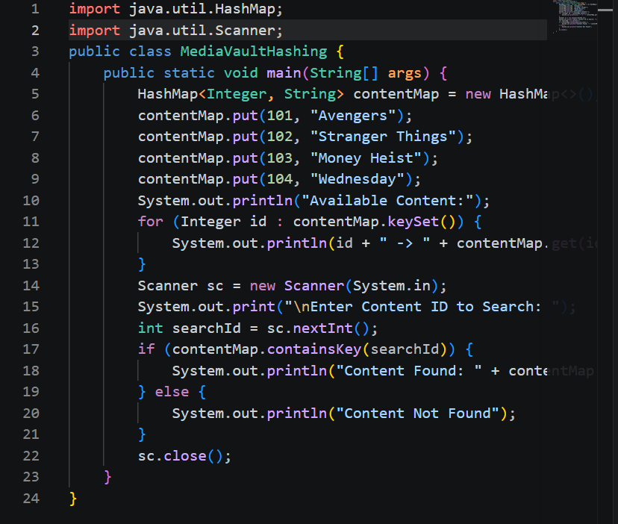

Output:-
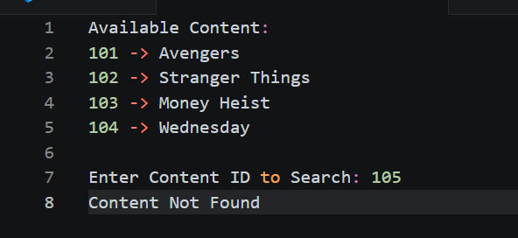

The Hashing-based system provided fast and efficient content retrieval. Compared to traditional searching methods, Hash Tables significantly improved search speed and enhanced the user experience on the Media Vault platform..

GitHub Link: https://github.com/snehiths399-byte/MediaVault--Digital-content-streaming-and-Analytics-system/commit/e13badaff9be0149df0d460482f0dd91139e5ab5
Student Signature Faculty Signature

